|  |  |  |  |
| --- | --- | --- | --- |
| **S.No.** | **Type of Event** | **From Date** | **To Date** |
| **1** | **BATTLE OF BANDS @ VJIT** | **1ST MARCH,2024** | **1ST MARCH,2024** |
| **2** | **BATTLE OF BANDS @ KG REDDY INSTITUTE OF TECH.** | **6TH MARCH,2024** | **6TH MARCH,2024** |
| **3** | **BATTLE OF BANDS @ VNR VJIET** | **16TH MARCH,2024** | **16TH MARCH,202** |
| **4** | **FLASH GIG @MGIT** | **18TH MARCH,2024** | **18TH MARCH,2024** |
| **5** | **BATTLE OF BANDS @MGIT** | **22ND MARCH,2024** | **22ND MARCH,2024** |
| **6** | **VOICE HUNT @MGIT** | **23RD MARCH,2024** | **23RD MARCH,2024** |
| **7** | **MAIN STAGE PERFORMANCE – NIRVANA ‘24** | **23RD MARCH,2024** | **23RD MARCH,2024** |

**Name of the club: SYMPHONY (MUSIC CLUB OF MGIT)**

**PHOTOS**

**BATTLE OF BANDS @VJIT**

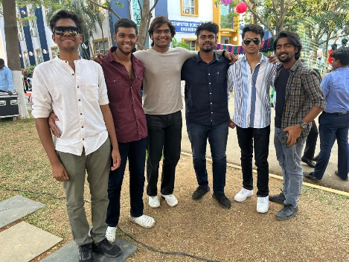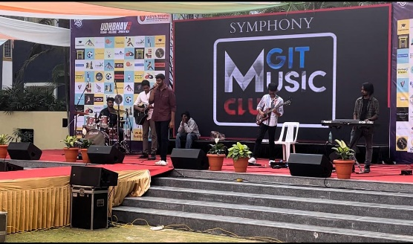

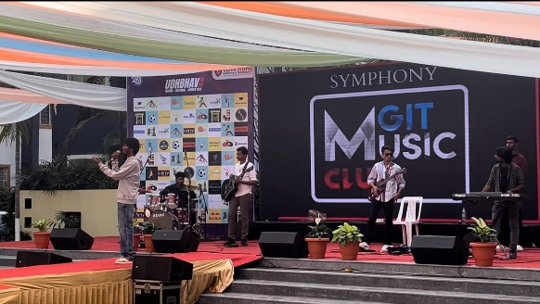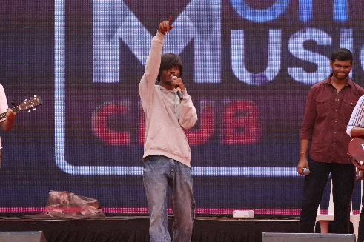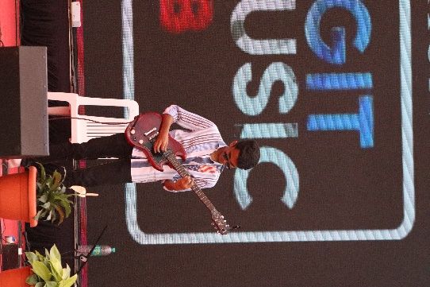

**BATTLE OF BANDS @KG REDDY INSTITUTE OF TECH.**

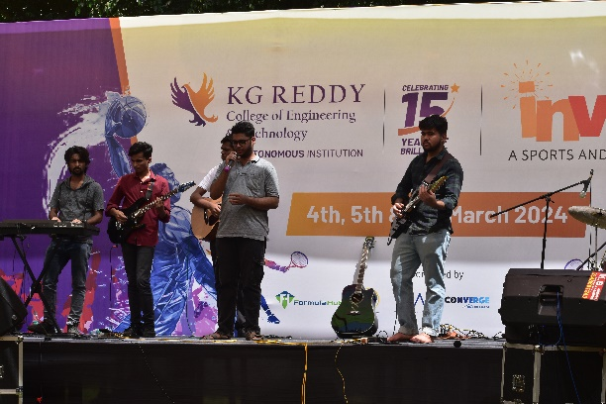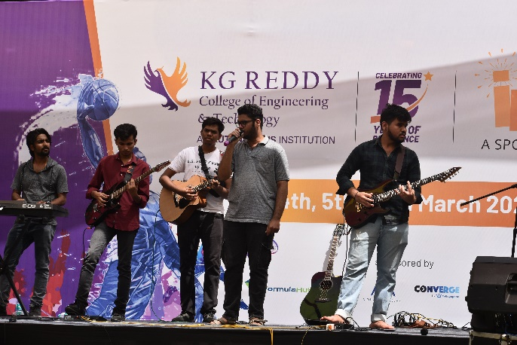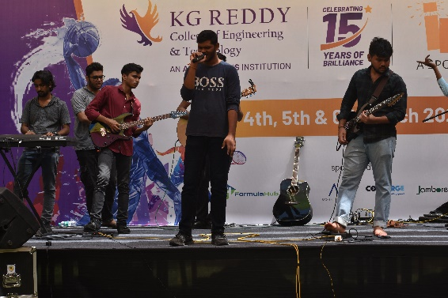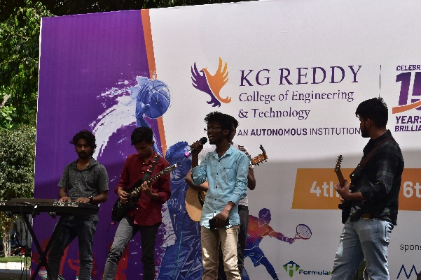

**BATTLE OF BANDS @VNR VJIET**

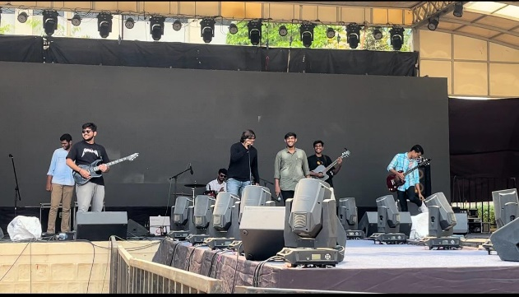

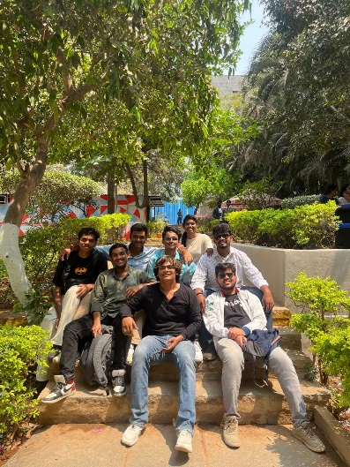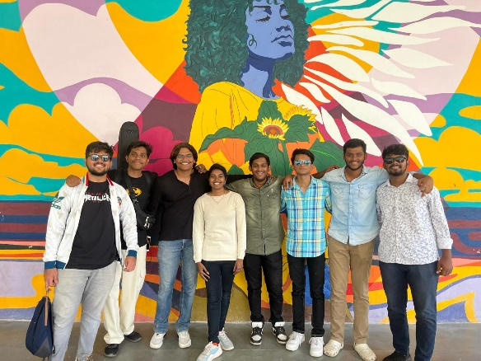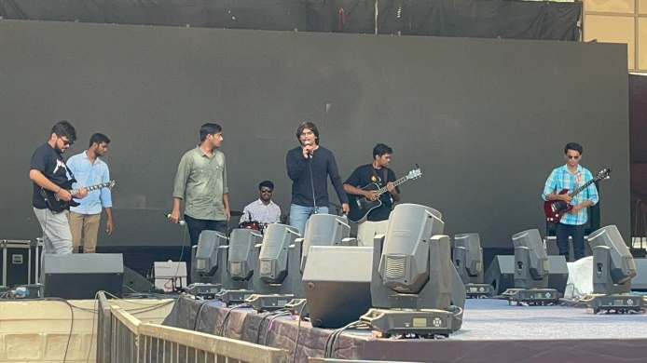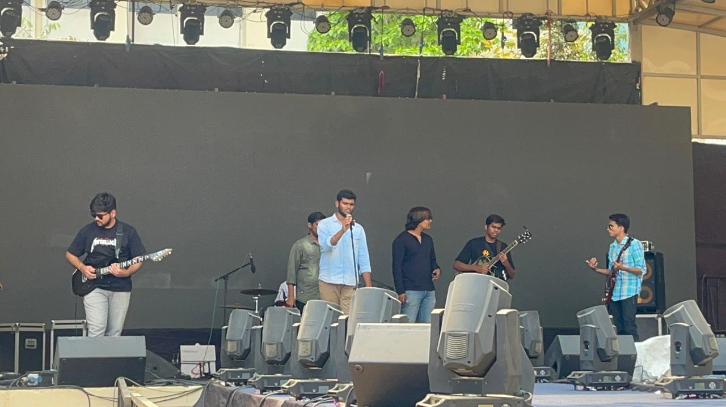

**FLASH GIG @MGIT**

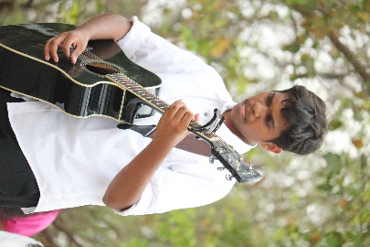 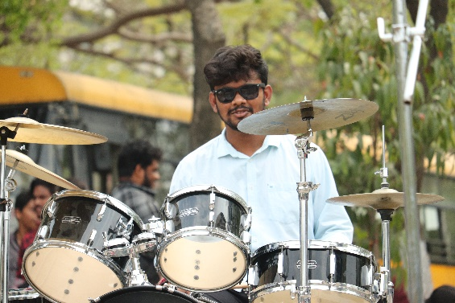 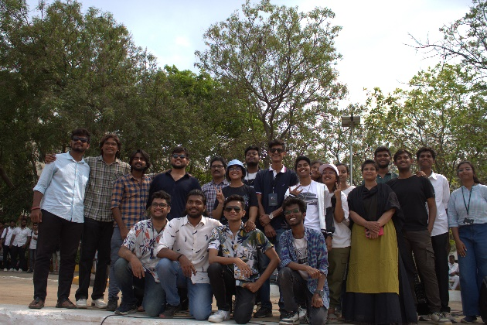 

**BATTLE OF BANDS @MGIT**

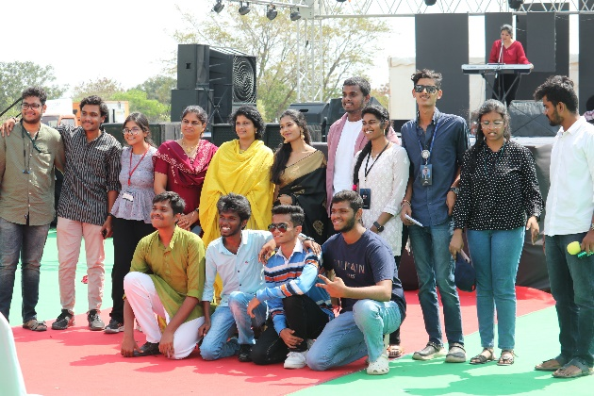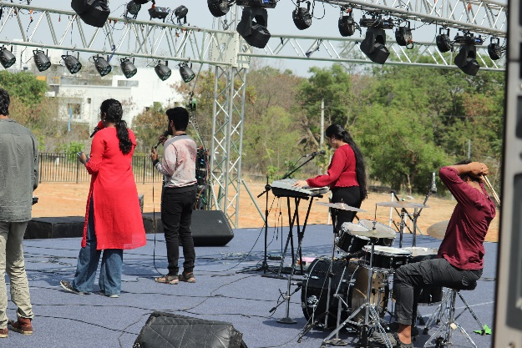

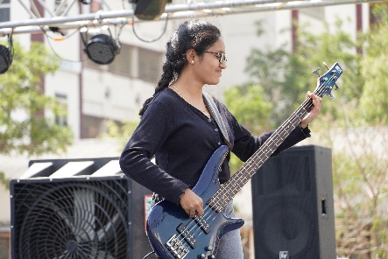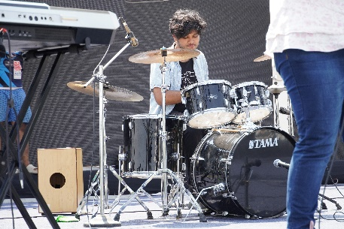

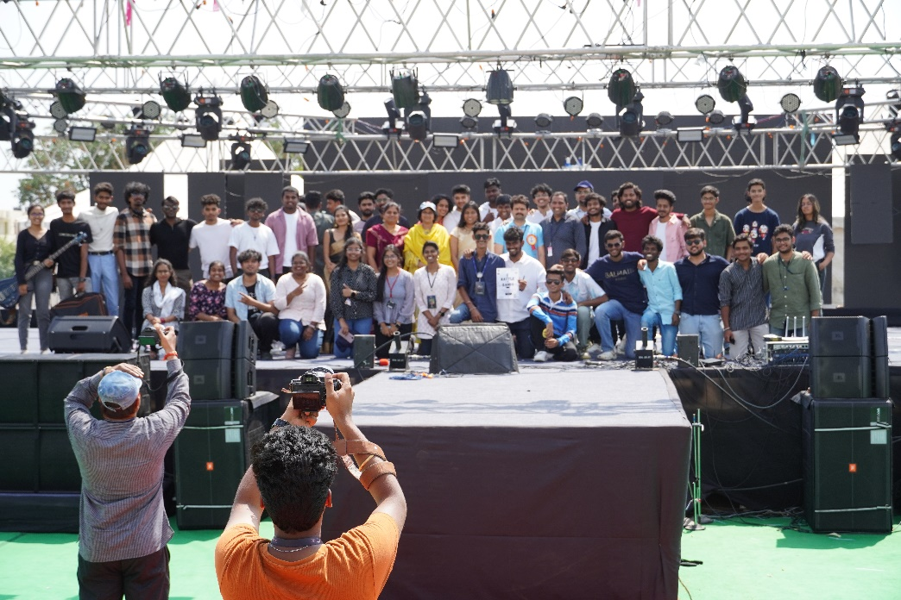

**VOICE HUNT @MGIT**

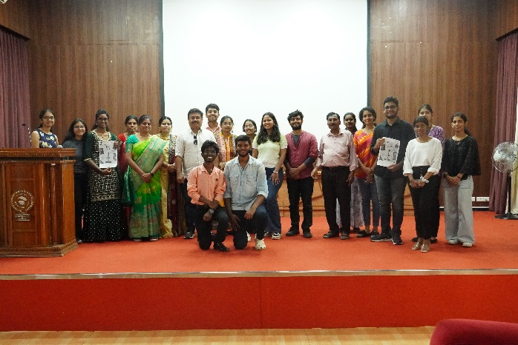 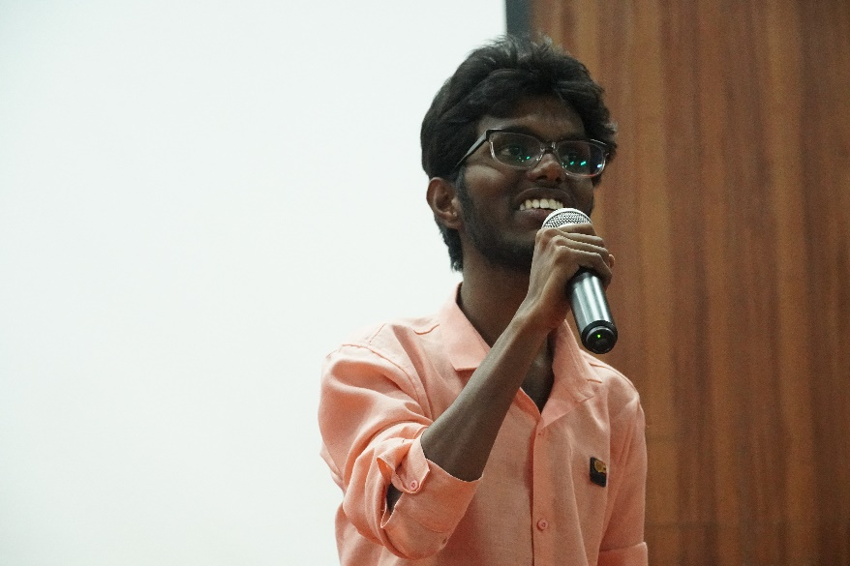

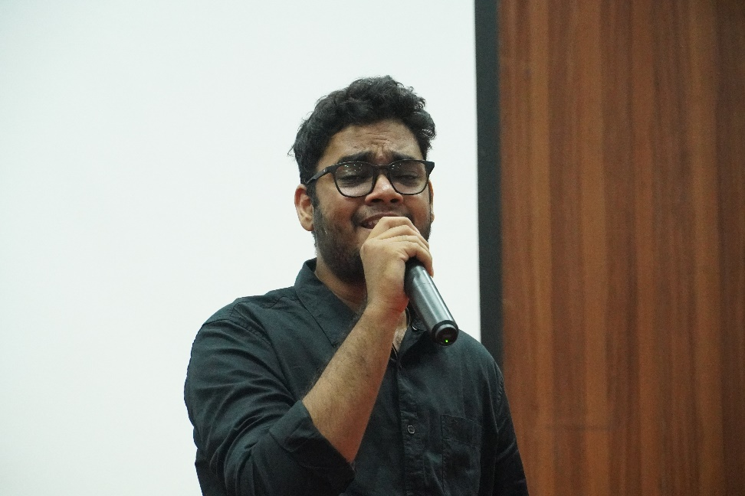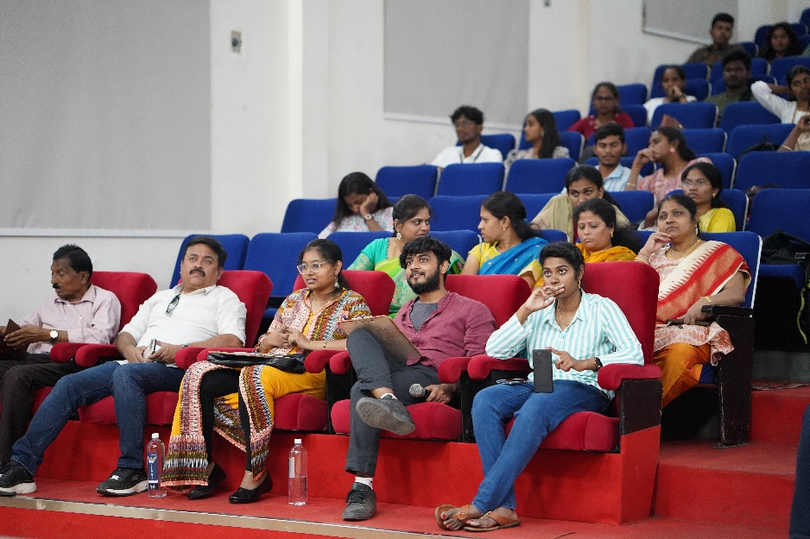 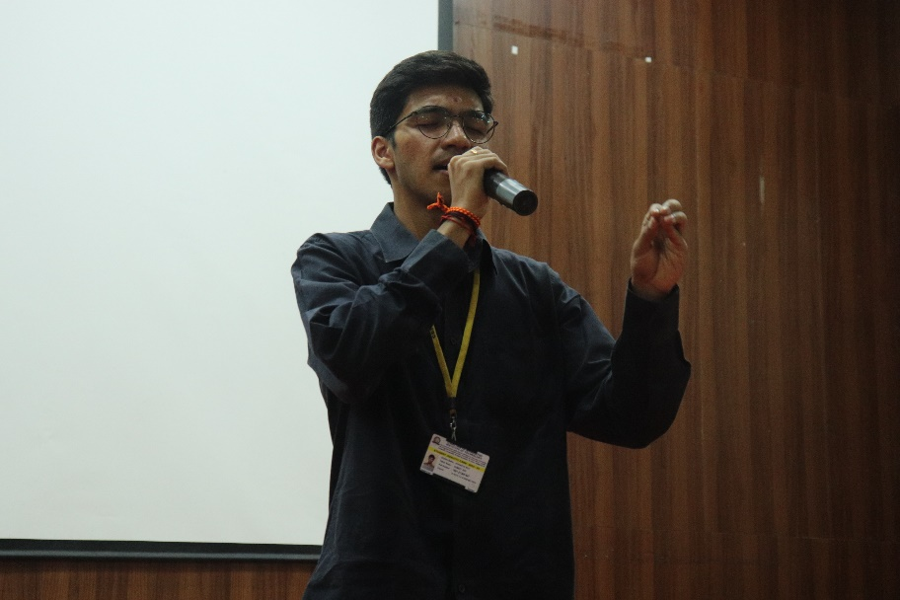

**MAIN STAGE PERFORMANCE -NIRVANA ‘24**

